**Terms of Reference**

**Midline Study: Survey Management System for Deployment of Android Technology**

**The Gambia Maternal and Child Nutrition and Health Results Project Impact Evaluation**

**March 2016**

# PURPOSE OF THIS CONSULTANCY

The purpose of this consultancy is to provide technical assistance and IT services for the deployment of a survey management system that employs Android tablets and ODK technology during the implementation of a midline survey that includes household, health facility, and community surveys.

# BACKGROUND

The Gambia is a small country in West Africa with a population of approximately 1.9 million (2013). The population has been growing at a fairly high rate of 3.3 percent per year over the last decade. The Gambia is a low income country with average per capita Gross National Income (GNI) estimated at US$510 (2012) which is less than half of the sub-Saharan African average of US$1,255. The 2011 Human Development Index shows the country at rank 168 out of 187 countries. Life expectancy at birth for the average Gambian is 58 years.

The Gambia’s performance on MDGs 1c, 4 and 5 has been mixed. While better off than the sub-Saharan African average for under-five mortality rate (U5MR) and maternal mortality ratio (MMR), when compared to sub-regional peers like Ghana and Senegal, The Gambia’s performance is lagging behind. U5MR and MMR have declined since 1990, but the progress has been modest in relation with the MDGs 1c, 4 and 5. Preliminary data from the 2013 Demographic Health Survey (DHS), if confirmed, would show encouraging results for U5MR having dropped to 54 per 1,000 live births. No such indication exists for maternal mortality or nutrition. The preliminary data from the 2013 DHS shows no change in underweight prevalence, i.e., 16 percent. According to the 2013 State of the World’s Mothers (Save the Children 2013), The Gambia ranks 170 out of 176 countries on the Mother’s Index just above Mali, Niger and Central African Republic but behind countries like Chad, Guinea-Bissau and Nigeria.[1]

Quantitative and qualitative assessments conducted at the household and facility levels indicate a number of barriers to better health and nutrition outcomes. The majority of demand-side constraints occur at the household or community level (except for attitude of providers toward patients) and is related to cultural obstacles, cost, inconvenience, and inadequate understanding about risks of conditions and benefits of seeking care or adopting a particular behavior. On the supply-side, the reasons for poor outcomes stem from the health system experiencing insufficient financing; inconsistent infrastructure, equipment and supplies; and inadequate training and motivation of health providers. The poor performance of the health service delivery system on maternal and child nutrition and health outcomes point to an operationally weakened and under-funded Primary Health Care (PHC) system and inadequate linkages between communities and the health sector. Total expenditure on health per capita in 2010 was $26 and the total expenditure on health was six percent of GDP. General government‘s expenditure on health as percentage on total health expenditure is 51 percent; out-of-pocket money by poor families 24 percent; and external resources 25 percent.

To address these challenges, a new project is being implemented to improve primary health care and community nutrition using an RBF approach. The development objective of the project is to increase the utilization of community nutrition and primary maternal and child health services in selected regions of The Gambia. This project targets women of reproductive age, including adolescents, and children under five focusing on the community level strategies which build on the integrated BFC and PHC strategies of National Nutrition Agency (NaNA) and the Ministry of Health and Social Welfare (MOHSW). This is being implemented in five of the seven Regions (North Bank West Region, Upper River Region, Central River Region and the Lower River Region).

In collaboration with the MOHSW and NaNA, the World Bank team has developed an evaluation to assess the impact of the above mentioned RBF interventions. A central goal of the HRITF is to learn about and document the extent to which RBF policies are effective, are operationally feasible, and in what circumstances. As such, rigorous evaluation of all RBF programs is essential for generating new knowledge that can inform governments and partners to effectively design and use RBF mechanisms. The eventual learning objective is not only to assess the impact of the RBF intervention(s) in The Gambia, but also to compare these impacts across the other countries with similar interventions, and to be able to provide externally valid advice on the feasibility and effectiveness of these approaches to other countries.

# IMPACT EVALUATION DESIGN

The two main interventions introduced as part of the pilot project are described in the following:

**Intervention 1: Community mobilization for social and behavior change (Community RBF)**. This intervention will focus on community-based promotion of key family and community practices and health care seeking behaviors for improved maternal and child nutrition and health outcomes through:

* + 1. Provision of *conditional cash transfers to communities and village support groups (VSG)* to increase demand for and utilization of health and nutrition services through counseling and timely referrals for life-saving health services (e.g., hygiene, sanitation, counseling on infant and young child feeding, delayed first pregnancy and child spacing, referral of pregnant women and children with danger signs to health centers);
    2. Provision of *conditional cash transfers (CCT) to individual women* to increase utilization of timely antenatal care; and

**Intervention 2: Delivery of selected primary health care services (Health facility PBF).** This component aims to support and incentivize the delivery of selected nutrition and health care services at primary health centers, and, where needed, also referral health centers. Health centers will receive performance-based payments for the delivery of a predefined package of maternal and child health and nutrition services at primary and referral health care facilities. A fee-for-service (FFS) mechanism which includes quantity and quality payments for a defined package of maternal and child health and nutrition services will be used.

The overall approach for the evaluation is a randomized phased in 2 x 2 design (Figure 1). The preliminary plan for the supply-side foresees facilities in the three target regions to be enrolled in the project in two phases. In discussion with the Project Implementation Committee (PIC), it was decided that each phase for the supply-side roll-out will last 18 months which should provide a sufficiently long time window to allow the impact evaluation team to observe behavioral change. In total, 24 facilities will be enrolled: 12 selected facilities will be enrolled in Phase I (including the 3 facilities already enrolled), and 12 facilities will be enrolled in Phase II.

**Figure 1. Study design**

|  |  |  |  |
| --- | --- | --- | --- |
|  |  | **Supply-side RBF:**  **Health Facility** | |
|  |  | Comparison | Treatment |
| **Demand-side RBF: Community** | Comparison | A | C |
| Treatment | B | D |

*Group A:* control group – receives neither the supply-side health facility nor the demand-side

community RBF interventions

*Group B:* intervention group – receives the demand-side community RBF only

*Group C:* intervention group – receives the supply-side health facility RBF only

*Group D:* intervention group – receives both supply-side health facility and demand-side

community RBF interventions

In addition to the supply-side interventions, some communities in the target regions will be enrolled in a community-based demand-side component, for which each phase will last 12 months. With an estimated target population of approximately 567,000 people we expect the demand-side RBF intervention to work only with selected communities in each health center catchment area. There are more than 800 communities in the target areas overall; at the beginning of the project, a meeting with community leaders will be held, during which two communities will be selected for the demand-side RBF in each facility catchment area (yielding a total of 48 communities). The rollout of the community incentive intervention will be spread out over 3 years; in year 1, a total of 48 communities will be targeted (2 per facility) for the impact evaluation; in each of years 2 and 3, an additional 48 communities will be included. During the first year of the intervention, communities will work towards and receive payments against a given set of objectives. Objectives will be monitored (through LQAS) and rewarded on a quarterly basis in the first year. In the second year, communities will be asked to maintain the achieved targets; if they achieve this objective, a final payment is made at the end of the second year, when communities graduate from the intervention. It is important to note that the monitoring efforts will increase over time: in the first year of the intervention, a total of 48 communities will need to be monitored on a quarterly basis; in the second year, 48 communities will need to be monitored on a quarterly basis, while 48 additional communities (those enrolled in year 1) will need to monitored once at the end of their second year.

To measure the community-level impact of the project, three main surveys will be conducted: a baseline survey was conducted at the beginning of the project; a midline survey will be conducted approximately 18 months after project launch, and an endline survey after approximately 36 months of the project. Figure 2 summarizes the time line of the survey monitoring plan. We have a mixed-methods explanatory design with an embedded process evaluation to explore pathways of impact according to the conceptual framework outlined above.

**Figure 2 Timeline for household and facility surveys**

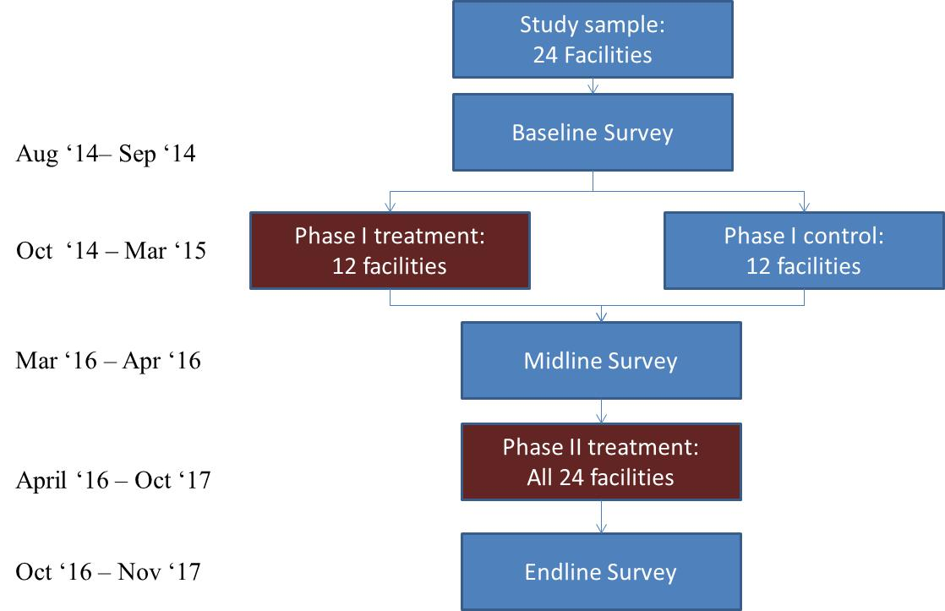

# SCOPE OF WORK

The objective of this consultancy is to provide technical assistance and IT services for the deployment of a survey management system that employs Android tablets and ODK technology during the implementation of a midline survey that includes household, health facility, and community surveys. The surveys will be conducted in three regions in The Gambia: North Bank West, Upper River and Central River Regions. In total, there are 24 Major and Minor health facilities in these three regions which will all be surveyed. In addition, household and community surveys will be administered within the catchment areas of the 24 health facilities. It is anticipated that data collection for the midline study will be implemented between July and August 2016. The below describes the data that will be collected for the midline survey:

| **Data** | **Who** | **Level** | **Type** | **Source** | **Survey Instrument** | **Description of Data** |
| --- | --- | --- | --- | --- | --- | --- |
| Household survey | Mother of the youngest child under 5 years in the household  n=2,400 | Household | Quantitative | Primary | Adapted Household Survey Instrument from the baseline survey | Health service use, health care seeking behaviors and barriers to use for MCH services, health expenditures, perceptions of health service quality |
| Household survey | Children under five  n=2,400 | Household | Anthropometry | Primary | Not applicable | Height and weight measurements |
| Community survey | VDC and VSG members  n=120 | Community | Quantitative | Primary | Community questionnaire (adapted from baseline survey) | Knowledge, perceptions, traditional beliefs, frequency and mode of activities, community ownership |
| Facility assessment | Facility in-charge  n=24 | Facility | Quantitative | Primary | Adapted health facility questionnaire from baseline survey | Facility staffing, infrastructure, drugs supply, equipment, supervision, HMIS reporting and management, user charges, facility revenue |
| Health worker interviews | Health care workers  n=96 | Facility | Quantitative | Primary | Adapted Health worker Questionnaire from baseline survey | Staff work load, compensation, motivation, satisfaction and knowledge |
| Patient exit interviews | Reproductive, maternal and child health and nutrition patients  n=192-288 | Facility | Quantitative | Primary | Adapted Exit Interview Questionnaires from baseline survey | Patient’s (or caretaker’s) perception of quality of care and satisfaction |

# TASKS AND DELIVERABLES

The overall objective of the consultancy is to provide technical assistance in the deployment and use of a survey management technology for use of tablets and ODK (Open Data Kit) for data collection and management for The Gambia MCNHRP IE midline survey. The service has to support the following features:

1. Real-Time and All-time communication between Base and Field
2. Forms update support: both minor changes (unstructural) and major changes (structural).
3. Push notification from Base to any specific tablet
4. Real-time data entry update (as long as an Internet connection is available) from tablets to Base. This feature allows Base to receive data in real-time, before enumerators submit the data so that error reports can be pushed to their devices and it is very easy to correct errors
5. Real-Time monitoring of device status: battery level, 3G status, Wifi status, Bluetooth status, Charging status (whether the device is charging or not). Base can push notifications to device to remind enumerators to prepare the tablet for the coming interviews
6. Supporting 3-layer management model including: Enumerators, Field Supervisors and Survey Managers
7. Supporting 2-layer Quality Assurance protocol: first layer implemented into the forms in the forms of hard constraints and soft alerts; second layer implemented on the server or supervisors’ tablets via R scripts
8. Ability to transfer data from enumerators’ tablets to Field Supervisor’s tablet without an Internet connection
9. Ability to allow Field Supervisors to submit data on behalf of enumerators
10. Ability to review interview instances that have been sent or finalized
11. Allowing Field Supervisor to review data collected by enumerators with preset probabilities
12. Ability to view monitoring & analytical reports of interview data in real-time

The firm will be expected to complete the following activities associated with this consultancy:

## ACTIVITY 1: Technical support for deployment of tablet-based survey instruments and survey logistics

The Survey Firm will provide the impact evaluation midline survey team technical training and support for the design, testing and finalization of all of the midline survey questionnaires, and provide access to a remote server for testing uploading and downloading of questionnaires. This will include the procurement of all devices and associated equipment.

***DELIVERABLES (1): The deliverables for this component are the 1) procured and programmed tablets (and chargers); 2) survey agenda and tools; and 3) the pre-training version of the survey instruments (produced by the IE team but under the support of the firm).***

## ACTIVITY 2: Training for use of the Survey System software

The Survey Firm will provide the impact evaluation midline survey team technical training and support for use of the Survey System platform for real-time tracking of interviews and data collection teams.

***DELIVERABLES (2): The deliverables for this component are 1) training materials for the use of the Survey System and 2) ready-to-use Survey System with preliminary programming for The Gambia survey.***

## ACTIVITY 3: Interviewer manual, training and pilot test phases

The Survey Firm is responsible for providing technical support and oversight for the preparation and execution of the interviewer training and pilot survey, including finalization of the interviewer manual. This includes support for development of training content; training of the data collection team in The Gambia (2 weeks: 1 week of training prior to data collection + 1 week of support during early data collection to troubleshoot); availability of servers for data collection practice during training and the pilot study; data cleaning of the pilot survey data; and technical feedback to the survey coordinators on the quality of the pilot test version of the survey instruments, logistics for the pilot survey data collection and data transferred to the server. The Survey System will also be used during the pilot survey.

***DELIVERABLES (3): The deliverables for this component are 1) finalized training materials and agenda; 2) finalized interviewer manual; 3) pilot survey data (cleaned); and 4) technical feedback on pilot survey.***

## ACTIVITY 4: Technical support implementation of the midline survey data collection

Throughout data collection, the firm will provide the IE team with the IT framework for data collection, including servers to host survey instruments and data, application of the Survey System, real-time monitoring and tracking of interviews in the field; provision of feedback to interviewers; cleaning of data and production of data sets on a regular basis; and overall support to the IE team.

***DELIVERABLES (4): The deliverables for this component are 1) finalized survey instruments, 2) Finalized set of quality checks (R-scripts), 3) Finalized set of monitoring reports that are available in real-time on the server as well as on the tablets of Enumerators and Field Supervisors.***

***ACTIVITY 5: Finalization of data set***

## At completion of data collection, the firm will provide technical support to the IE team for data cleaning and finalization of the midline survey data set. The firm will conduct final cleaning of the data and produce a final data delivery report

The final dataset and report must include:

* Final data files in STATA format (one data file for each questionnaire)
* All relevant STATA dofiles
* Variable names and data labels in STATA. Variable names generated by the program should correspond clearly and logically to the question labels used in the questionnaire.
* Coding strategy in order to maintain consistent, unique identifiers for households, health facilities and communities and to enable seamless merging of datasets as required
* Final completion numbers
* Completion inventory
* Codebooks that provide documentation and instructions for data users
* Monitoring reports that provide monitoring information during fieldwork

***DELIVERABLES (5): The deliverable for this component is 1) the provision of the final data set to the IE team 2) the final, cleaned data set; 3) Stata data files and dofiles; 4) the dataset dictionary with all variables labeled and defined; and 5) codebooka and final monitoring reports.***

# REQUIRED SKILLS/ EXPERIENCE

The selected organization will have the following characteristics:

.

1. A minimum of 5 years’ experience with conducting surveys in the health sector or in other social sectors in developing countries. Experience with conducting facility-based surveys is strongly preferred.
2. Experience with conducting large-scale surveys.
3. Experience with ODK tablet technology.
4. Strong team of computer programmers familiar with survey content and structure.
5. Strong capacity and experience in planning and organizing survey logistics.
6. Good network of experienced enumerators, supervisors and data entry clerks.
7. Strong capacity in data management and statistics.
8. Strong knowledge in the following software: ODK, ODK Aggregate, SPSS and STATA.
9. Strong interpersonal skills and a team oriented spirit.

In the technical proposal, the firm must also indicate the proposed staff and qualifications for each of the key managerial positions.

# ESTIMATED LEVEL OF EFFORT

|  |  |  |
| --- | --- | --- |
| **Deliverable** | **Date** | **Payment** |
| Signature of Contract | Month 0 | 10% |
| Activity 1: Technical support for development of tablet-based survey instruments and survey logistics | Month 1 | 40% |
| Activity 2: Training for use of the Survey System software | Month 2 |
| Activity 3: Interviewer manual, training and pilot test phases | Month 2 | 20% |
| Activity 4: Technical support implementation of the midline survey data collection and finalization of data set | Month 3-4 |
| Activity 5: Finalization of data set | Month 5 | 30% |

# SUPERVISION

The firm will work under the guidance of the Task Team Leader (Rifat Hasan, AFTHW) and Principal Investigator of The Gambia RBF IE team at the World Bank and in close collaboration with the Evaluation Coordinator of the IE. The firm is obligated to submit to the World Bank the output outlined in this Terms of Reference within one week of completing the assignment. All deliverables will be approved by the impact evaluation team.

# TIMELINE

This consultancy will begin May 1, 2016 and conclude with the completed report by December 31, 2016.

1. Indicators of the 2013 Mother’s Index include: (i) Lifetime risk of maternal death; (ii) Under-5 mortality rate; (iii) Expected years of formal education; (iv) Gross national income per capita; and (iv) Participation of women in national government